**Introduction to the Business Problem**

**Introduction**

Using Foursquare API, I am going to try and suggest restaurant in Peoria, IL (A small city down south of Chicago). I will then group these restaurants based on their similarities of cuisine so that a user can make an informed choice and have a satisfying outing at the place. I would also cluster the restaurants based on the region of the city to which they belong. This will help people identify which side of the city offers the choices they are looking for.

**Data Requirements and Methodology**

**Data Requirements**

For this project, I will be utilizing the Foursquare API to pull the following location data on restaurants in Peoria, IL:

* Venue Name
* Venue ID
* Venue Location
* Venue Category
* Count of Likes

**Data Acquisition Approach**

To acquire the data mentioned above, I will need to do the following:

* Get geolocator lat and long coordinates for Peoria, IL
* Use Foursquare API to get a list of all venues in
  + Get venue name, venue ID, location, category, and likes

**Methodology**

The core idea behind the segmenting is the number of likes provided to the restaurant. The more likes there are, the better the restaurant is. I will then bin this data into a quality categorical variable so that it can be clustered appropriately into possible 3 bins.

I am also going to create new categorical variables for the restaurants to better group them based on type of cuisine. This way you can look for the type of food along with the quality of the restaurant in that region

To do this I will use the data gathered using foursquare api, clean up and organize data according to the parameters we are looking for. And using k-means clustering algorithm we will cluster them into 3 categories so that people looking to eat in Peoria can have an informed choice based on the region of the city

**Results**

Running clustering algorithm, I was able to generate results and groups them per region

**Cluster 1**

North-East side of the city have mostly below average bars barring couple of great restaurants and cafes (refer notebook for full view)

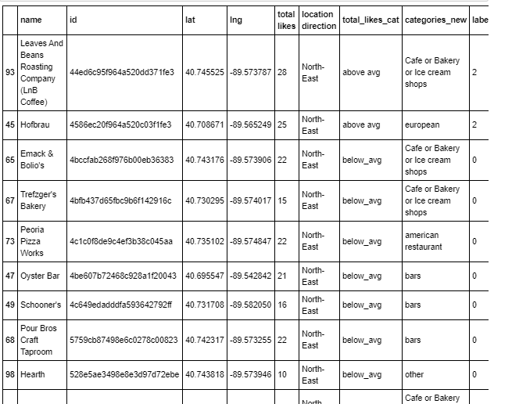

**Cluster 2**

North west side of the city has a greater number of food places and bars and it also the best choices from the city (refer notebook for full view)

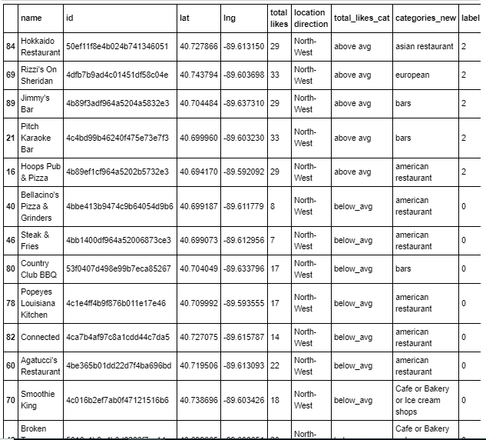

**Cluster 3**

South East side of the city has the most concentration of the American style food restaurants. It also has quite a many great places to pick from (refer notebook for full view)

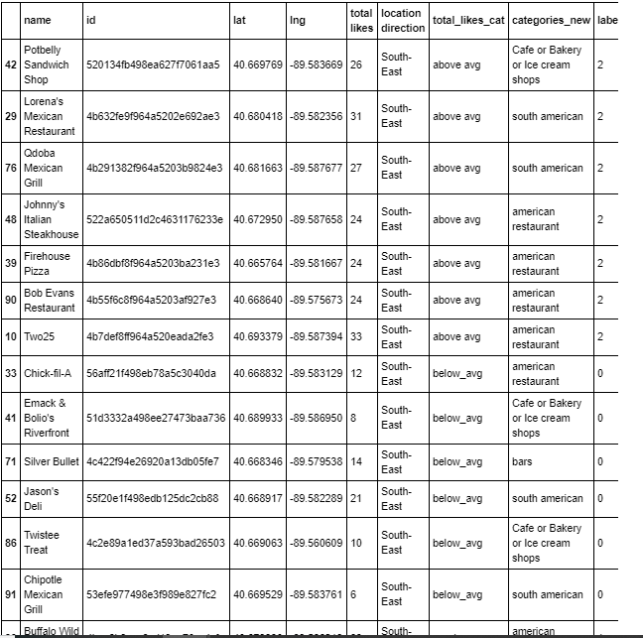

**Cluster 4**

South west has few great bars and couple of above average American restaurants (refer notebook for full view)

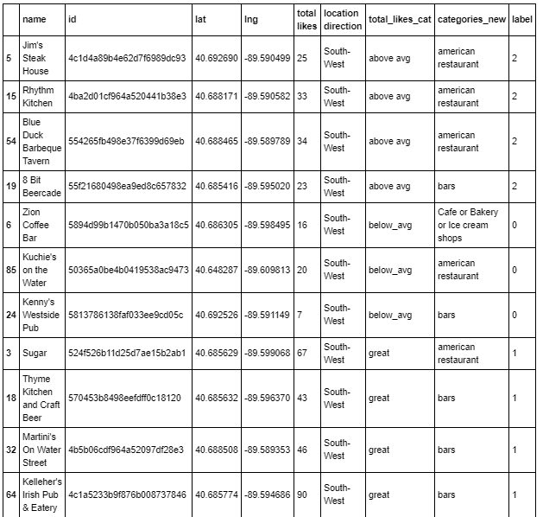

**Map of Clusters for Users**

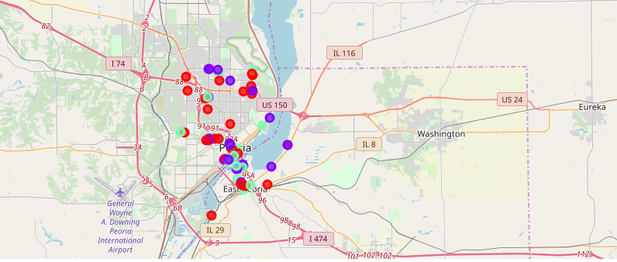

**Reference Notebook**

<https://github.com/Kiranv27/Coursera_Capstone/blob/master/final%20project/The%20Battle%20of%20Neighborhoods.ipynb>